**Wash Me Report**

**Scenario**

Customer login the app from customer section and set the car location then choose wash type and make the payment. After order complete employers be able to see customers cars location shown on employers map page.

The staff will take the customer’s car and he will wash it in the company’s car wash station. Meanwhile in the application, there will be a status page which will show the status at the car. The moment employer takes the car, the status will change to “Washing”. It will change after the washing process is done. This is going to help user to see all actions about the car.

After finishing cleaning an employer will bring the car back and finish the order, so location of the car no longer shown on the map.

Use Cases Are:

1. Customer or employer login the app
2. Customer set car location
3. Customers choose wash type and make the payment
4. Employers select the order from map
5. Employers change the status
6. Customers check the status
7. Employers wash the car
8. Employers bring the car back
9. Employers finish the order

Screenshots:

1. This is the Welcome Page

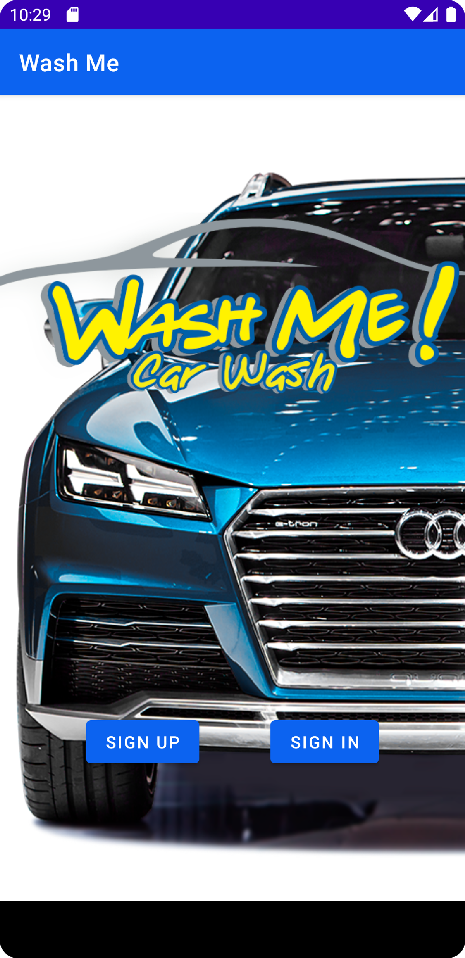

1. Firstly we have to sign up to login the app

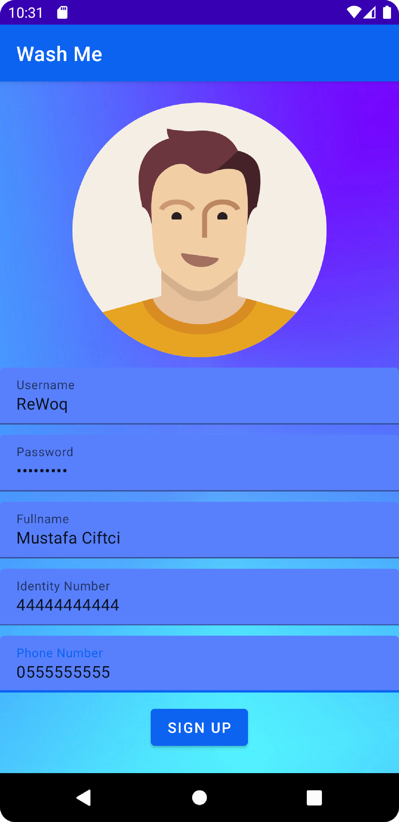

1. Then Login

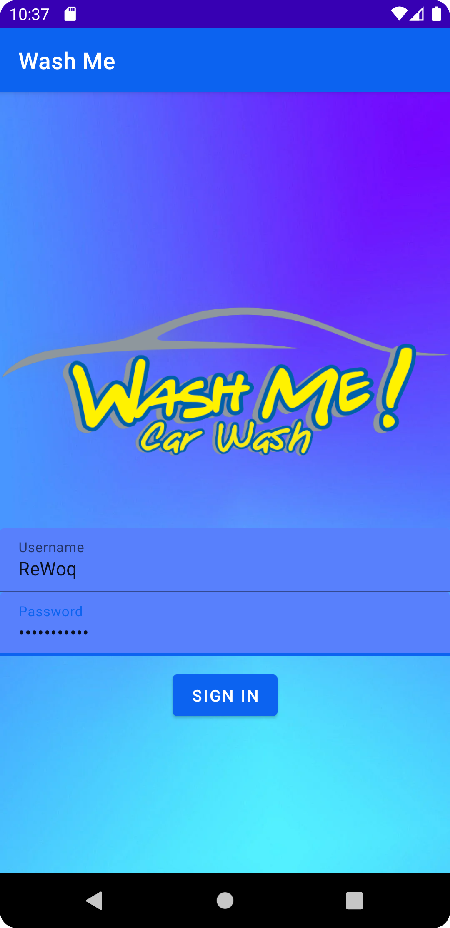

1. This is the profile page which we can change the profile picture and information and we can logout

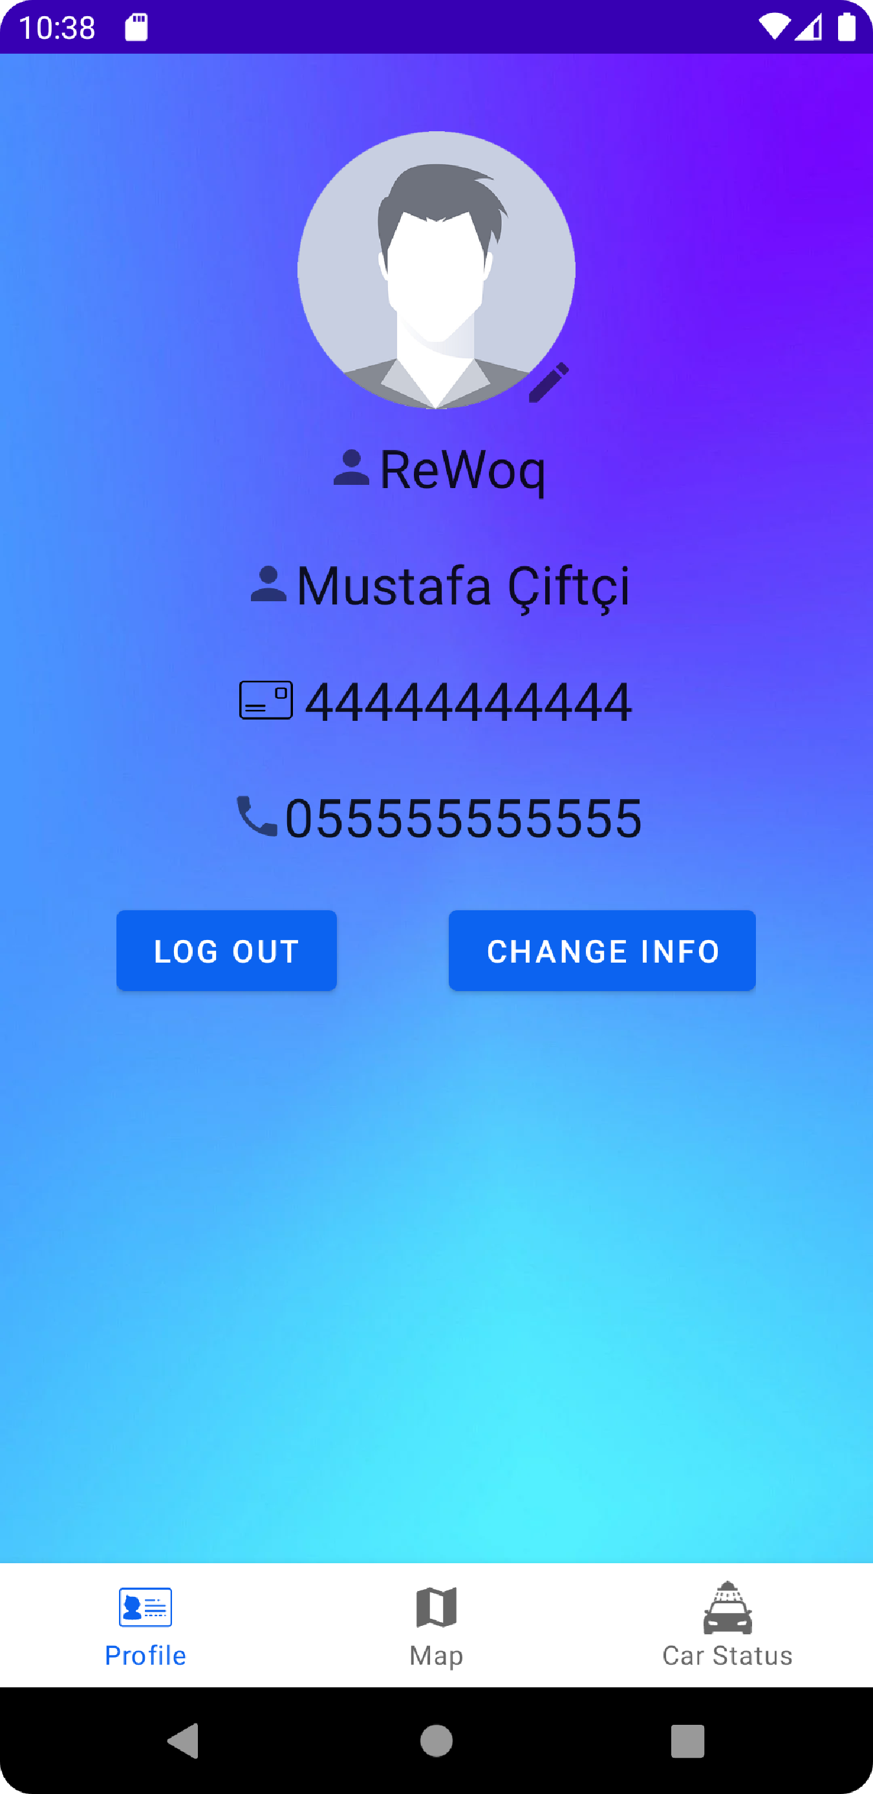

1. Firstly, we have to give the location permissions to use the map

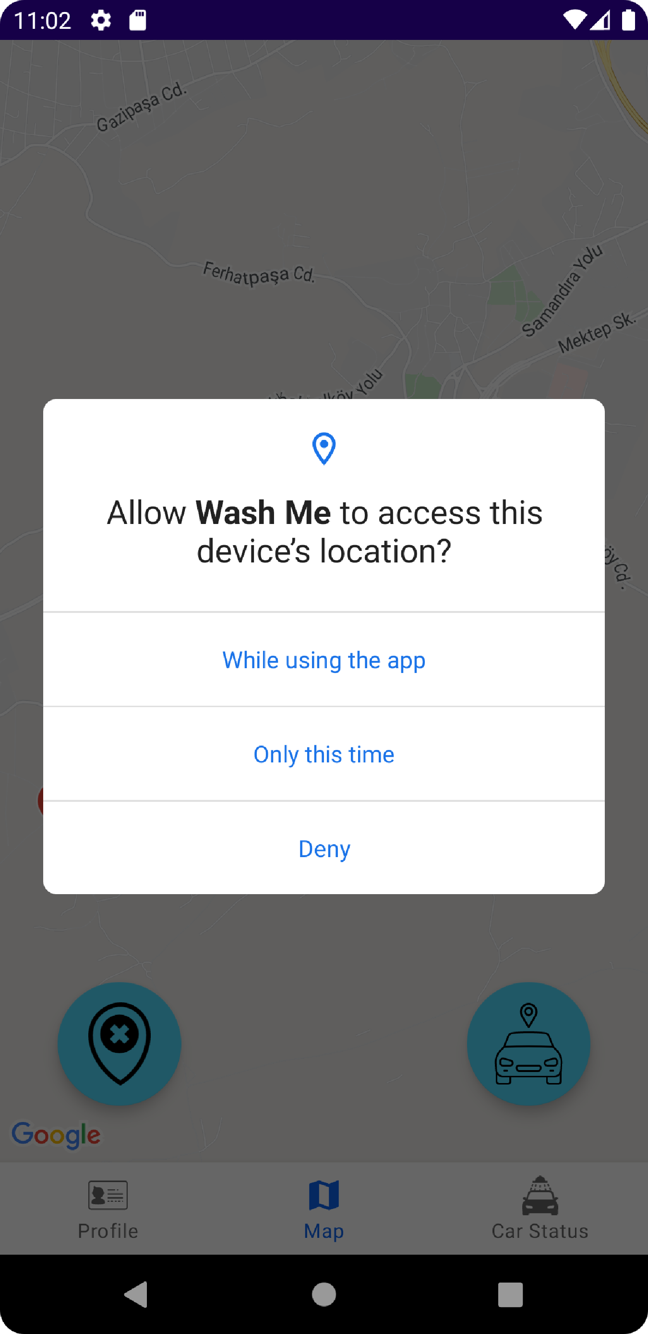

1. After give the permission you can see the map

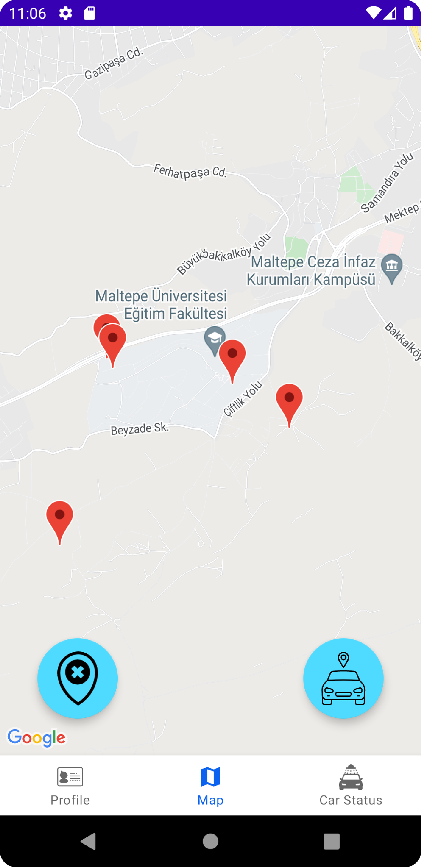

1. To give an order and choose the wash types we can select the button where is right side of the page

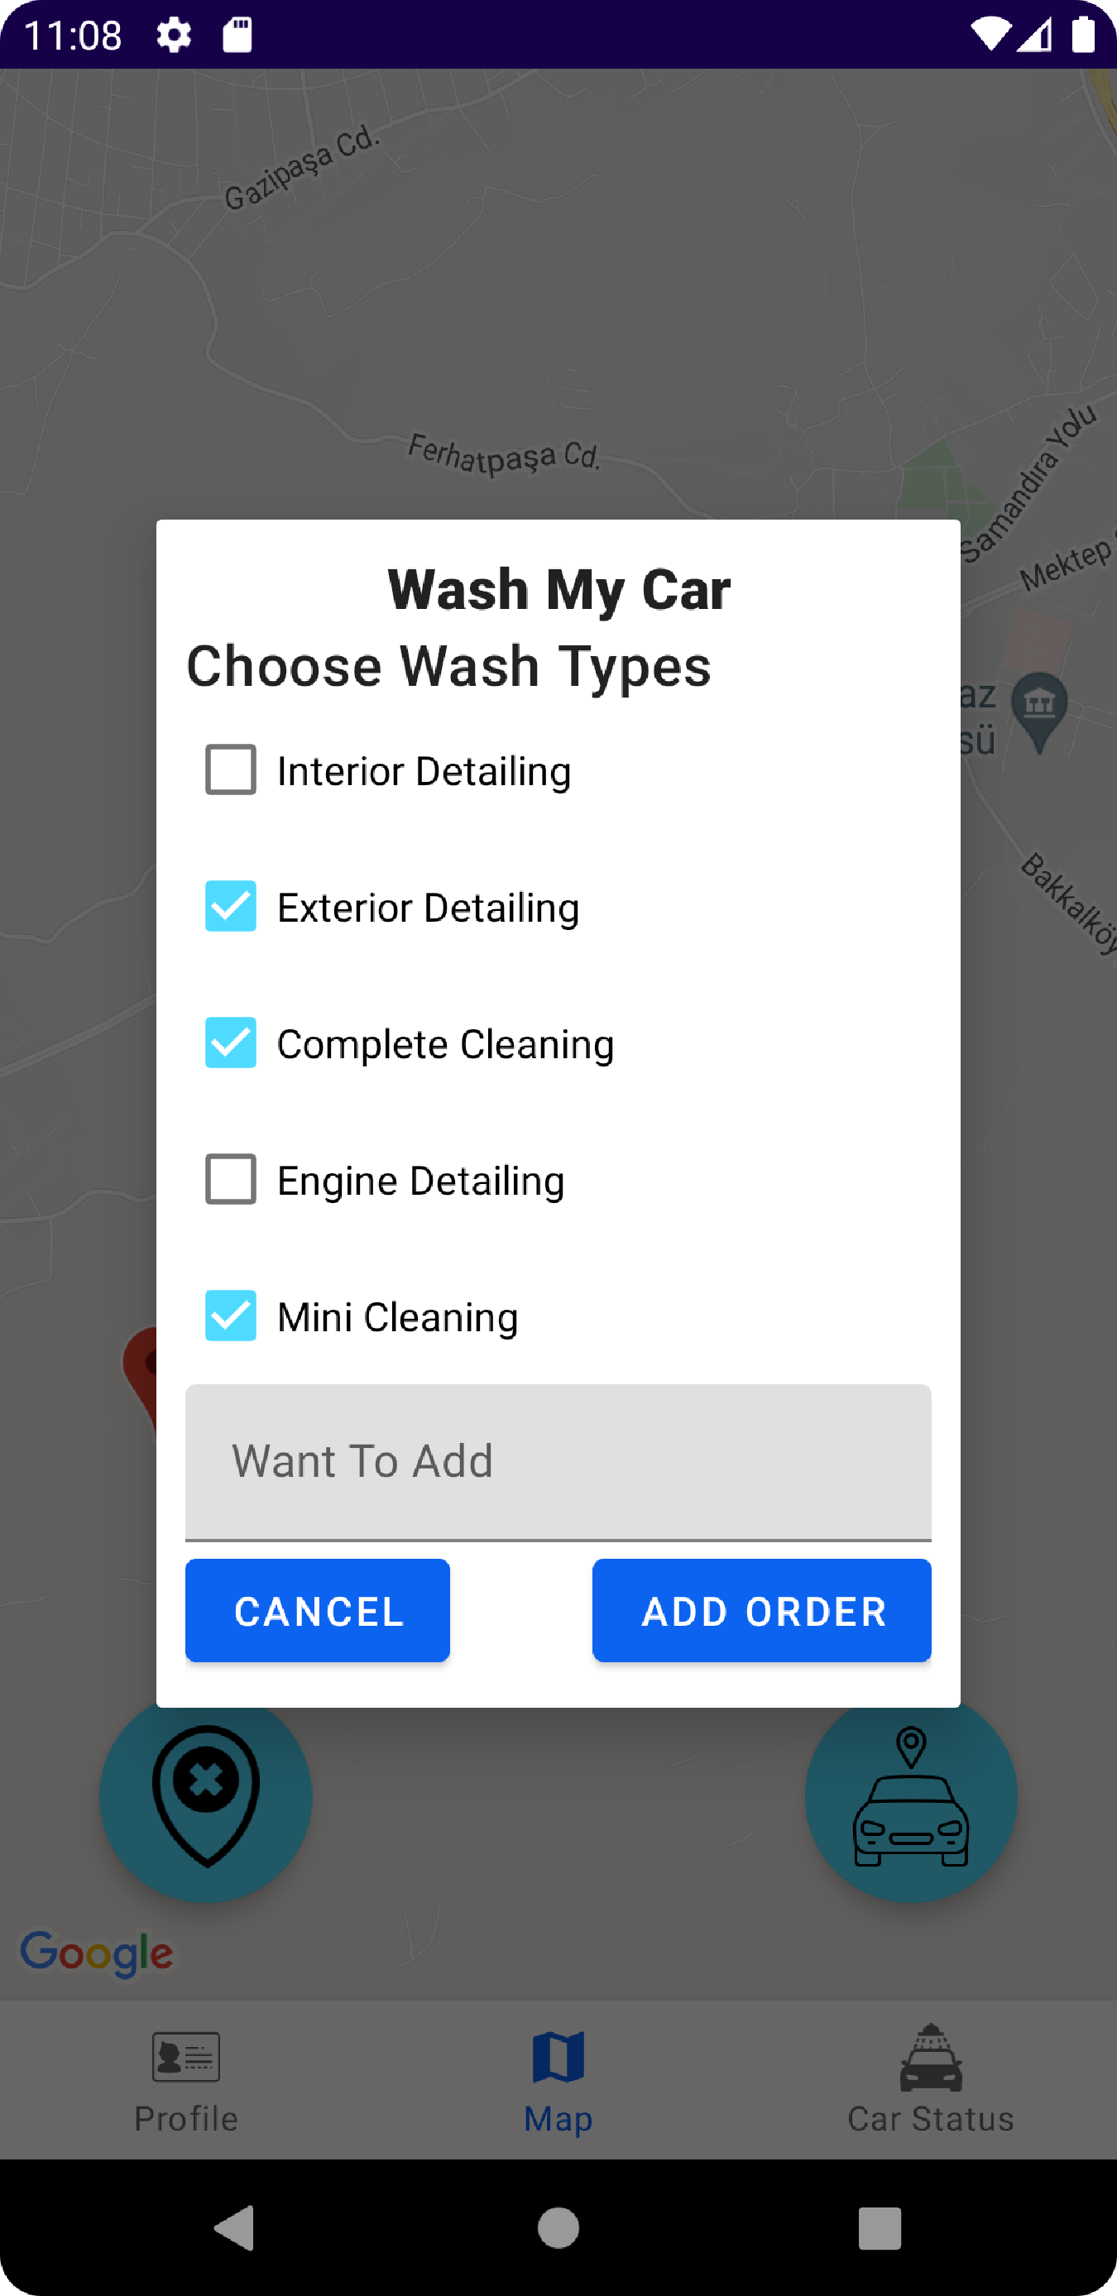

1. After selecting add order button app will take your last known location and show it on the map and employers can select your order after this process

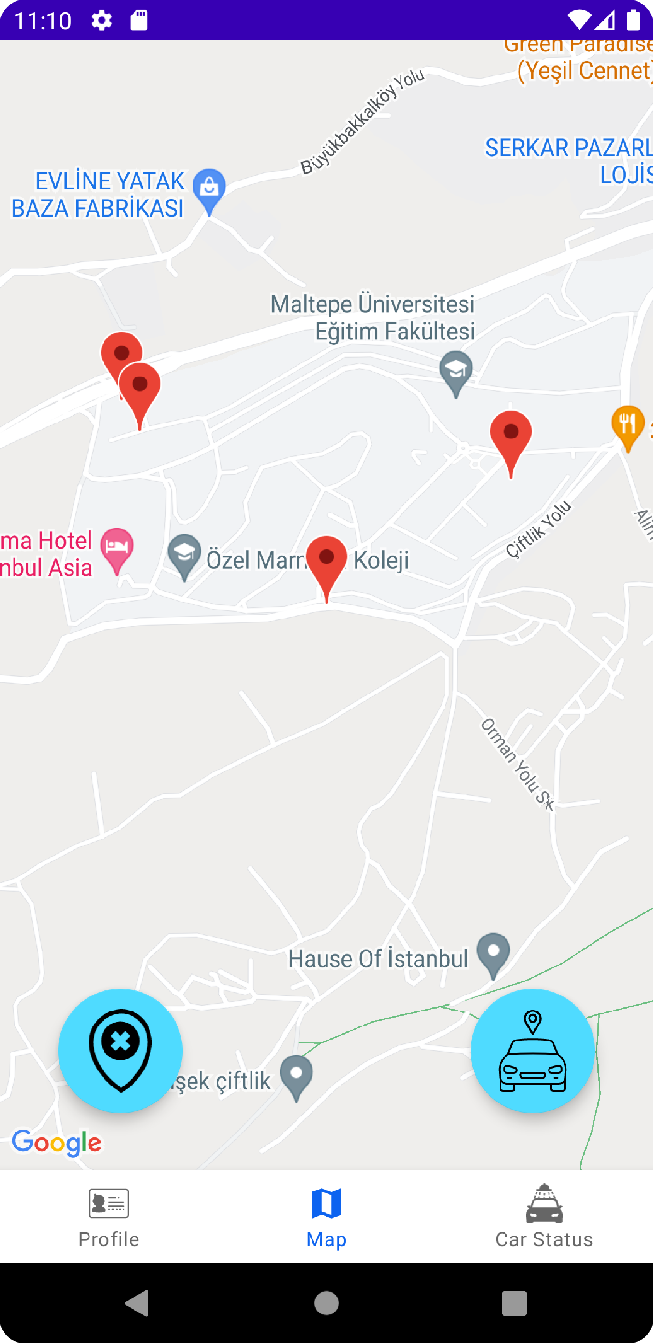

1. When we select the car status page, we can see the cars washing state. As we see here the car is washed and customers bringing the car back.

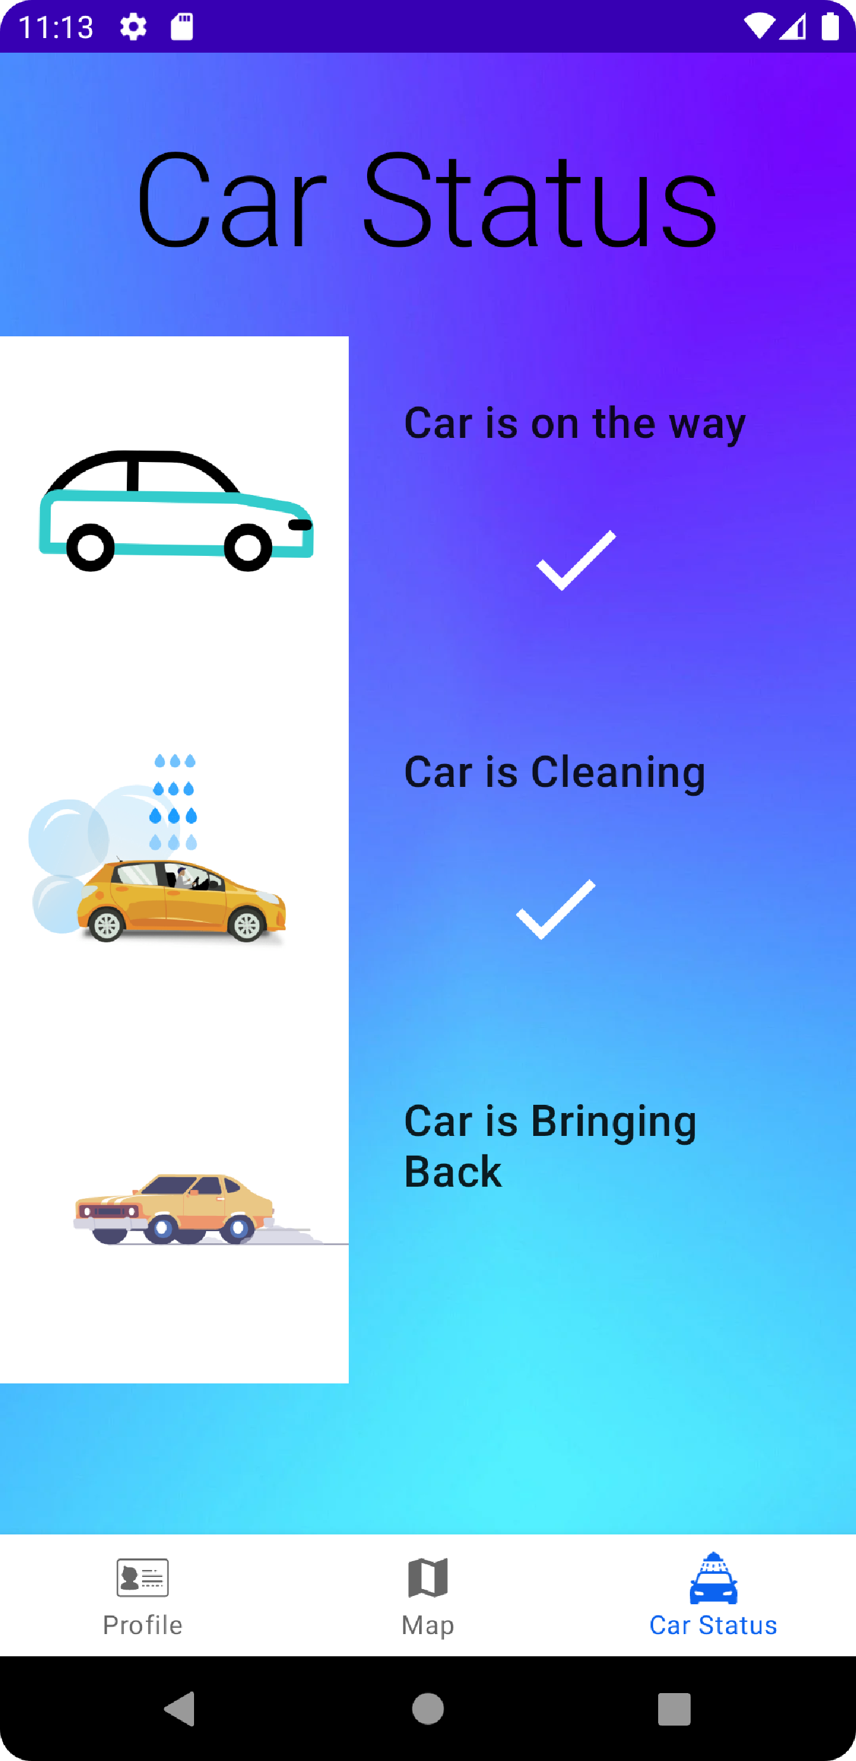

1. After car is brought back to its location customer can delete the order with the button where is left side of the map page

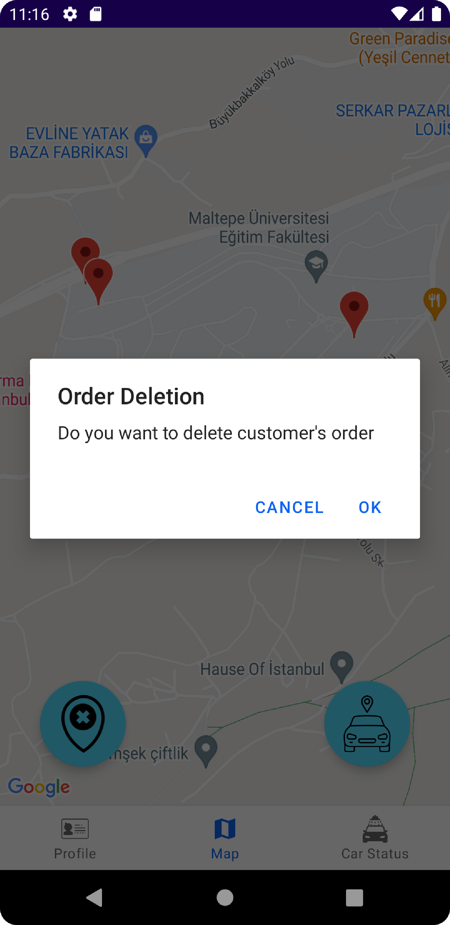

1. As we see here order is finished and deleted

